The Book recommender ontology is designed to represent the different entities and sub-classes related to the main class. With this organized structure we can represent relations between classes and sub-classes.

**Book** Class:

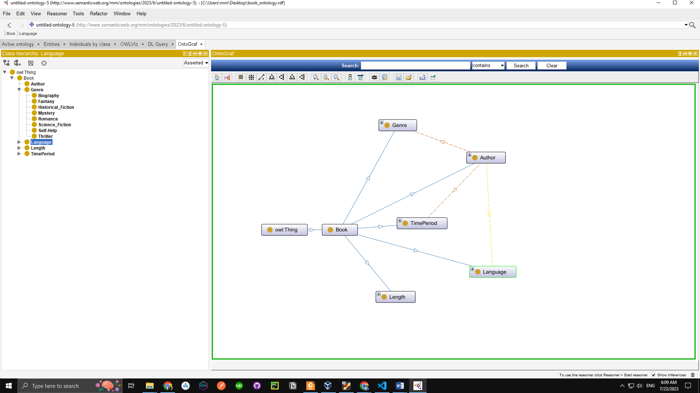

**Subclasses:**

* **Genre:** The "Genre" class categorizes books into different genres, such as Mystery, Romance, Fantasy, Science Fiction, Biography, and more.

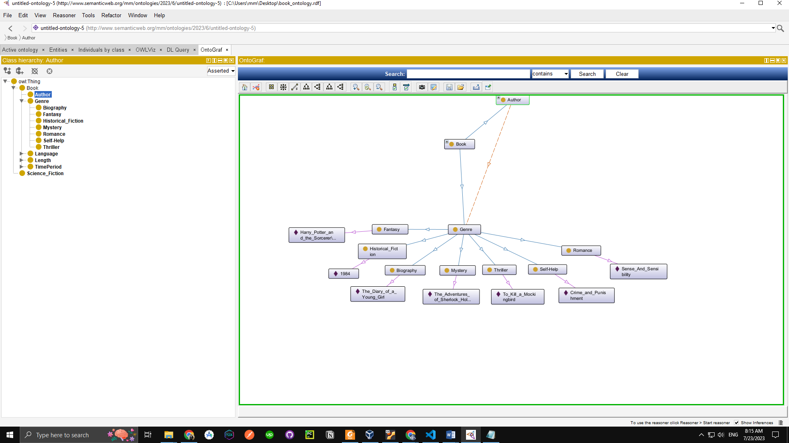

* **TimePeriod:** The "TimePeriod" class captures the time setting or historical period in which a book's events take place. It enables the categorization of books based on their temporal context, such as Medieval, Victorian, Modern, or Futuristic.

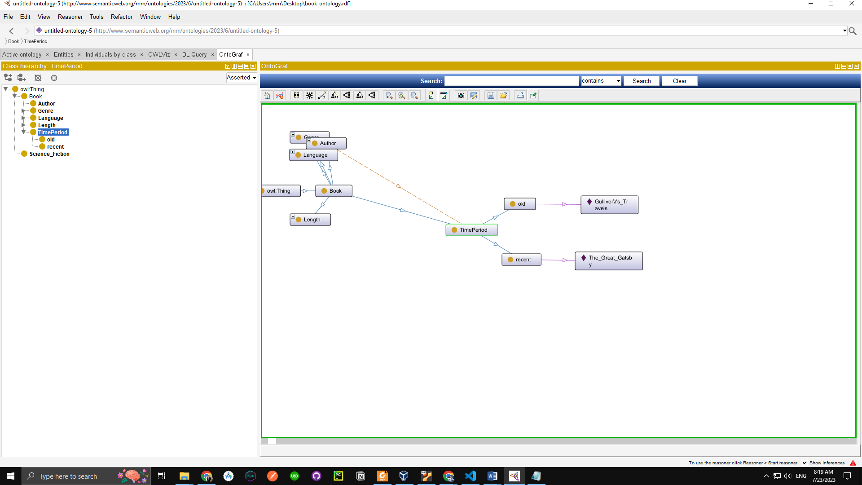

* **Length:** The "Length" class represents the size or length of a book, typically measured by the number of pages or word count. Books can be categorized as Short, Medium, or Long based on their length.

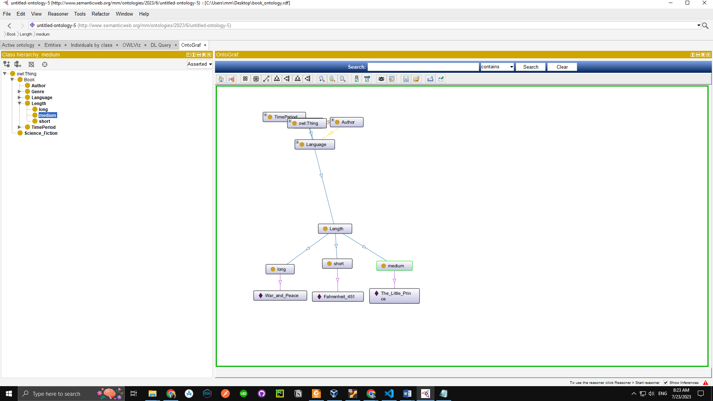

* **Author:** The "Author" class represents the creators of books. Each book is associated with one or more authors, facilitating searches based on author preferences.

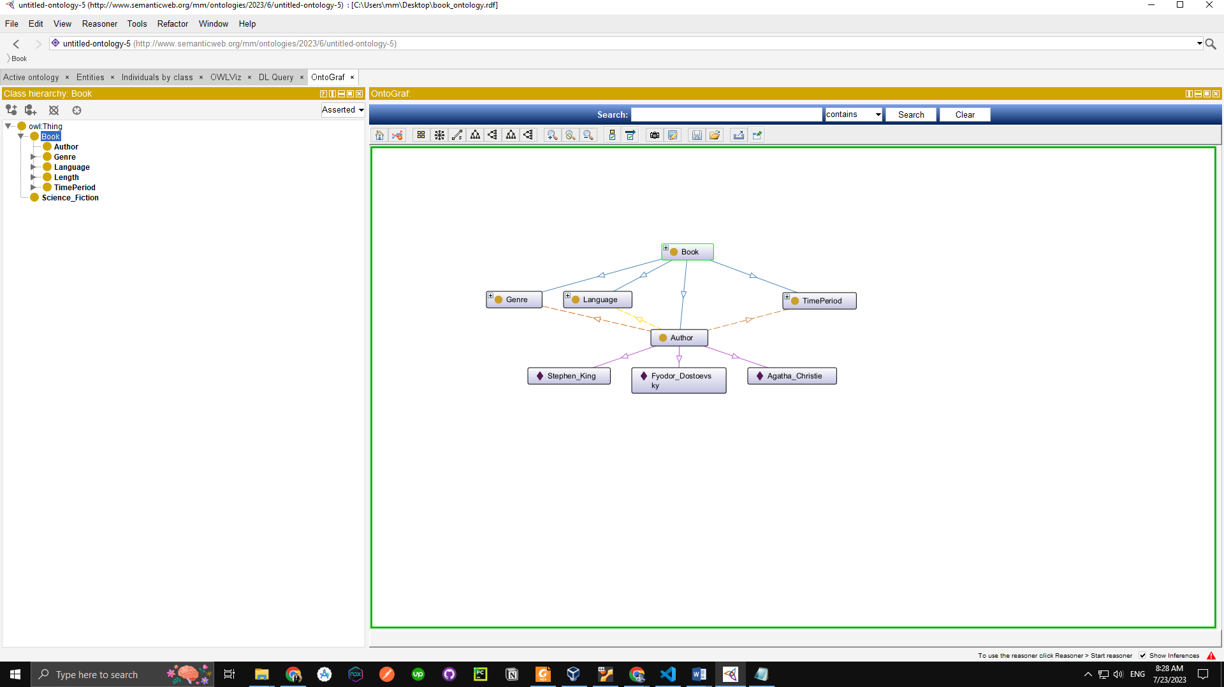

* **Language:** The "Language" class identifies the language in which a book is written. Books can be categorized by language, such as English, Spanish, French, and so on, enabling users to find books in their preferred languages.

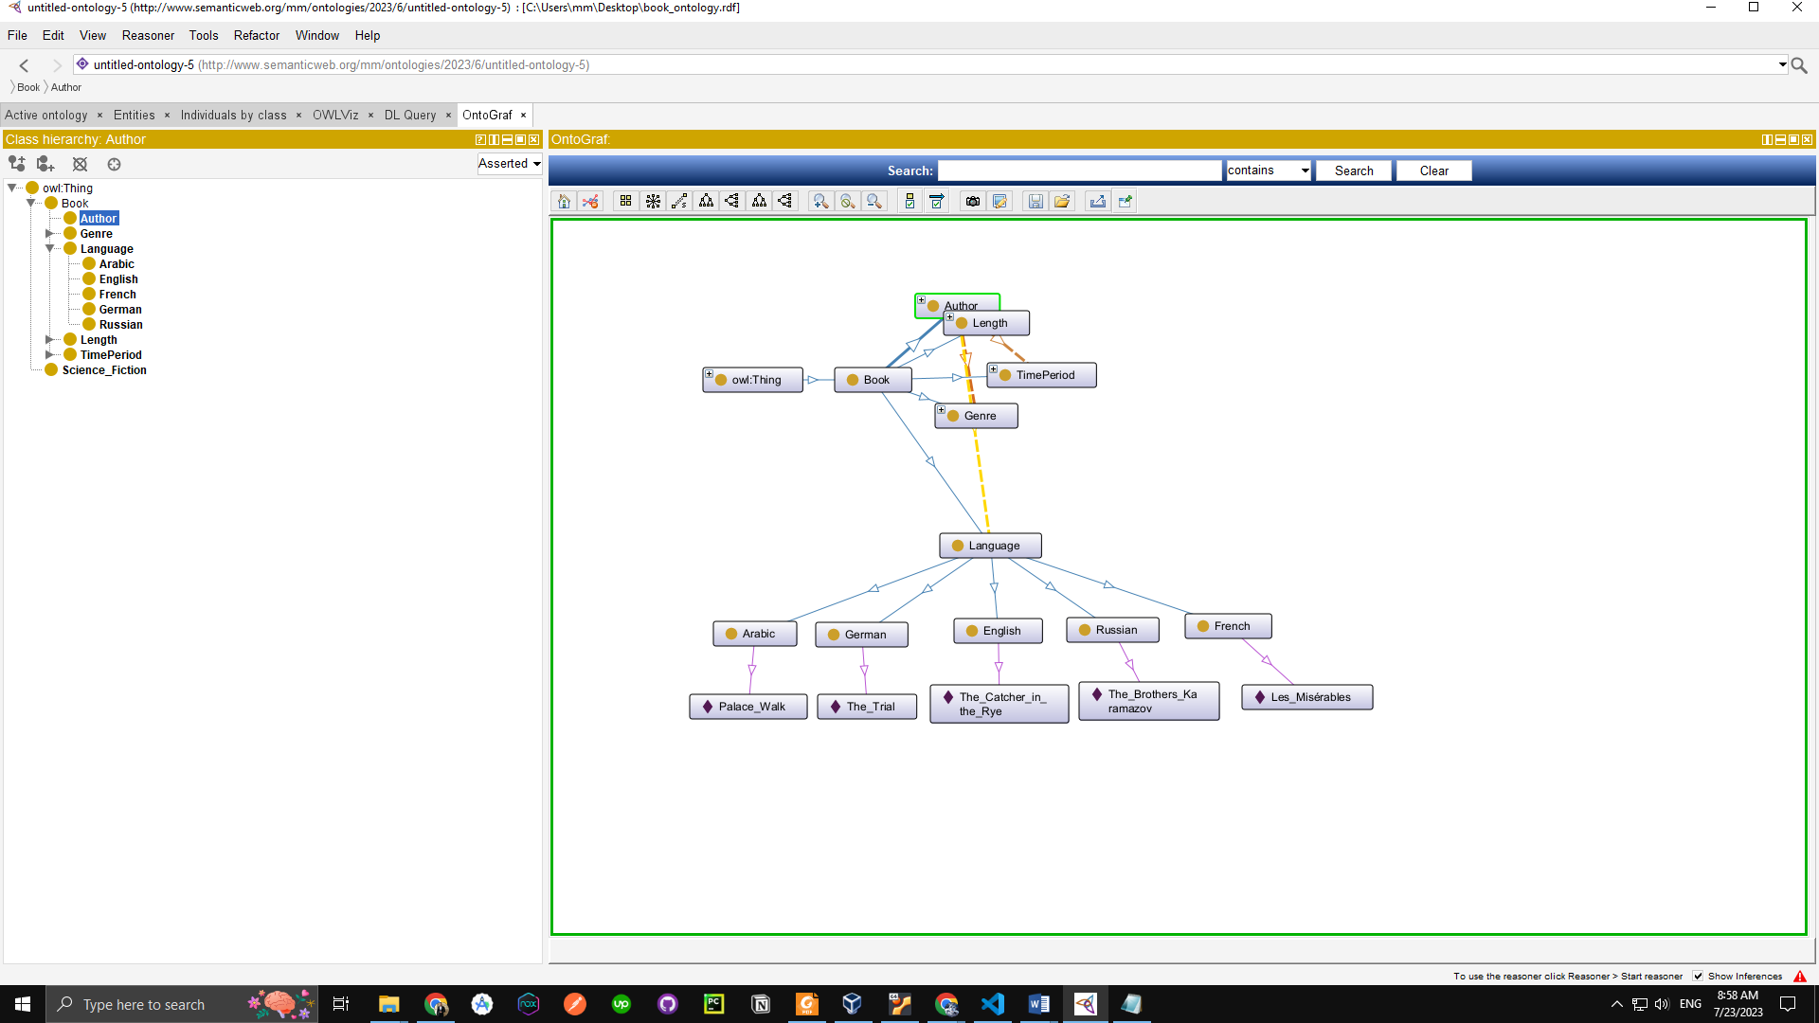

By utilizing these classes and their subclasses, the Book Recommender Ontology offers a comprehensive and organized approach to recommending books, making it easier for users to discover books of interest based on genres, time periods, lengths, authors, and languages.

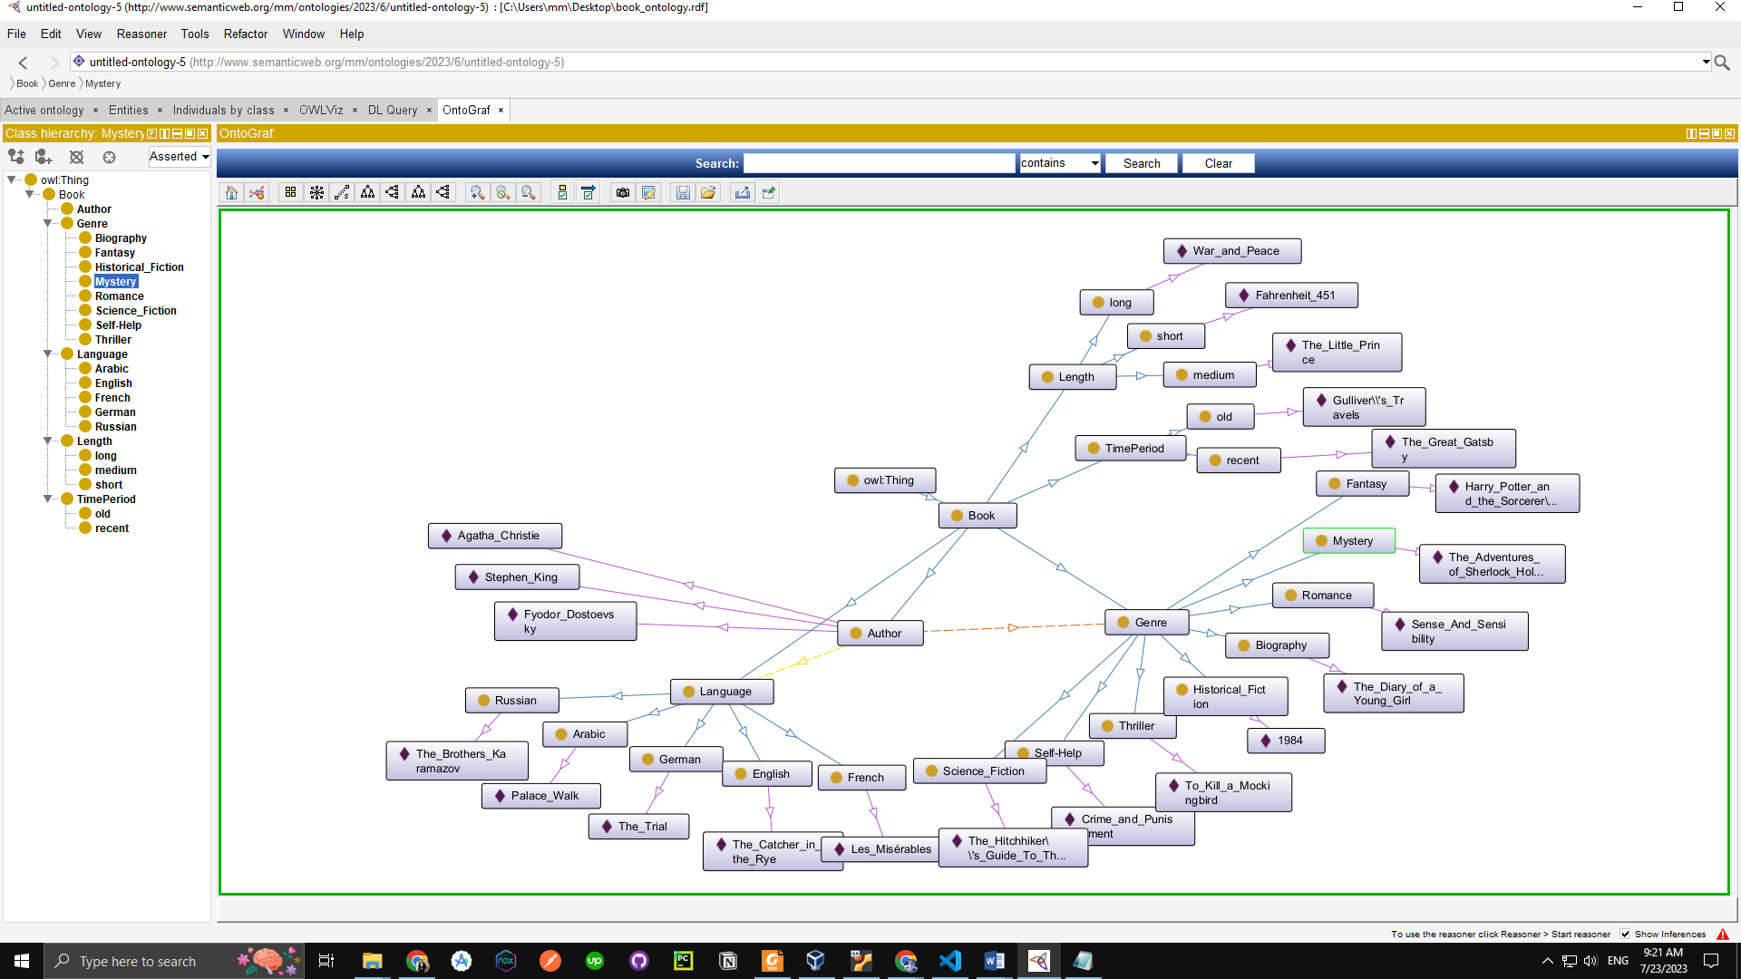 The final **OntoGraph**:

**Books Recommendation**

First, we defined our Intents which are genre, timeperiod, length, language, standalond and fiction

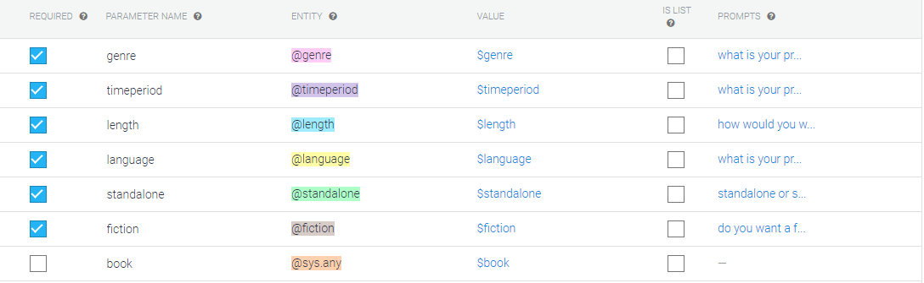these intents which will lead the way to get our recommended book

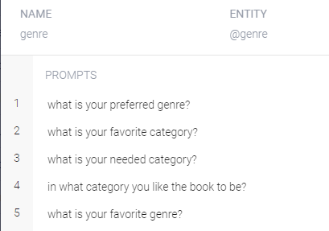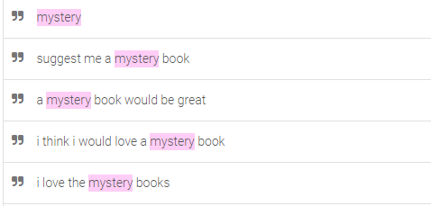for each intent we defined our prompts and training phases for **genre**

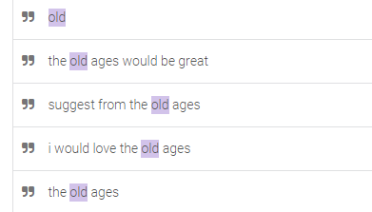for **time period**

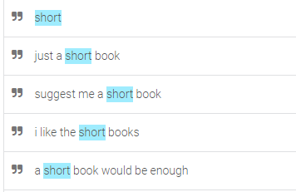

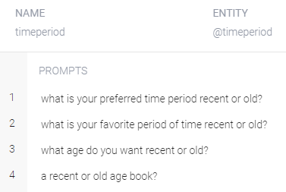for **length**

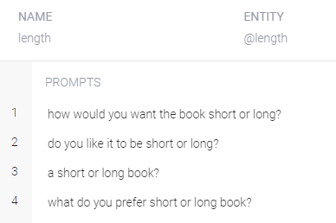for **language**

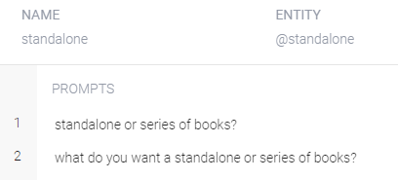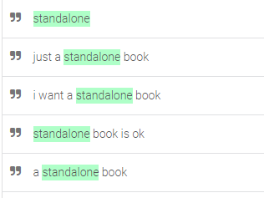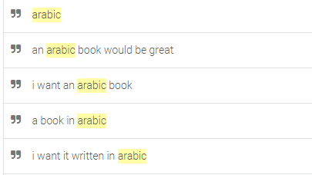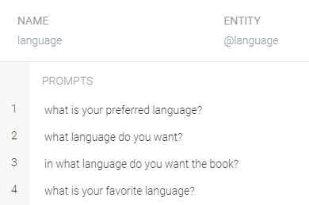for **standalone**

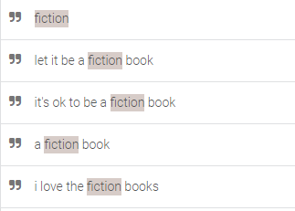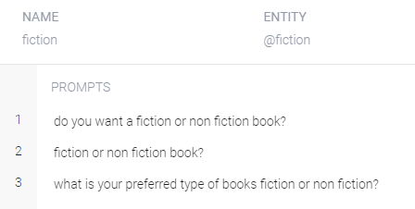For **fiction**

**Entities**

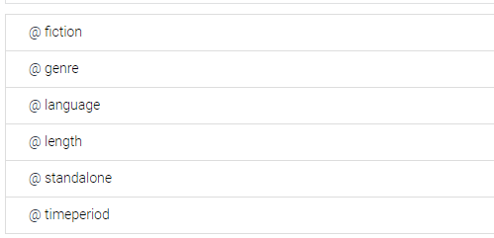

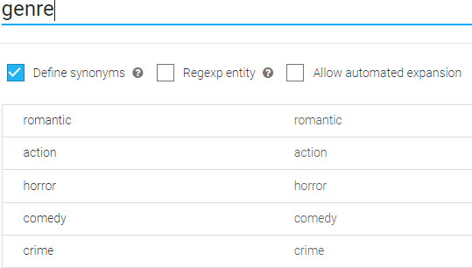

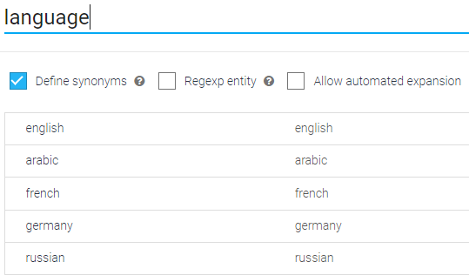

**Test cases**

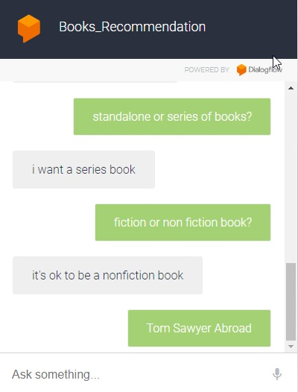

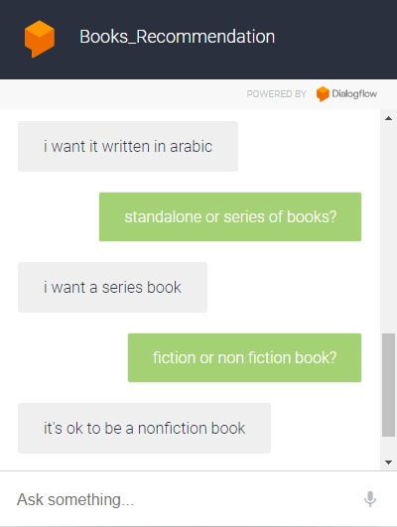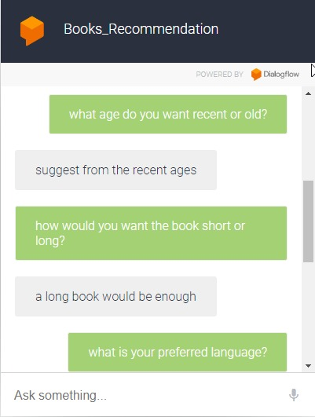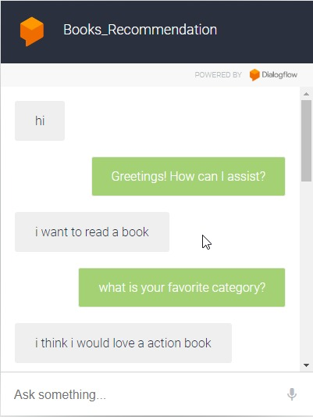

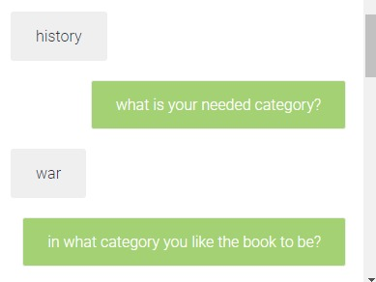**Weakness**

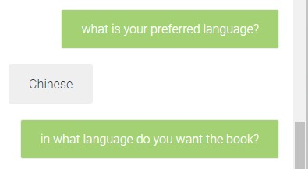**limitations:**

5 genres and 5 languages only

**The instance of the chatbot:**  
<https://bot.dialogflow.com/3afa33e0-495c-41a6-a39c-a27a4823d2c0>